PRACTICAL-6 STACK APPLICATION
Aim:- Write a program to covert infix to postfix and then evaluate the postfix.
Theory:- First infixtopostfix is where each and every expression is taken and checked until \0, which is by default at the end of every expression, is reached. If it is ‘(‘ push into stack, if it is any number it is entered into postfix expression and if it is ‘)’ every operator from the top of the stack poped and add to postfix expression until ‘(‘ expression is reached. If it is any operator then it is checked with top operator of stack. If ‘(‘ is there push in stack otherwise pop the operator at the top and add into postfix evaluator until low priority operator then the original operator is encountered then push it into stack. At last if any operator remains in stack transfer it to postfix expression.
In evaluation we scan and perform operations until ‘\0’ is encountered. If number is there then push to stack and if any operator is encountered then pop the last two operator then perform the evaluation and push the answer to stack. At last pop the element in stack that is the answer.
Code:-
#include<stdio.h>
#include<ctype.h>
int priority(char c)
{
if (c=='^')
return 3;
else if (c=='*' || c=='/')
return 2;
else if (c=='+' || c=='-')
return 1;
else
return 0;
}
void infixtopostfix(char exp[],char postfix[])
{
char stack[50];
int top=-1,k=0,i=0;
while (exp[i]!='\0')
{
if (isdigit(exp[i]))
{
postfix[k]=exp[i];
k+=1;
}
else if (exp[i]=='(')
{
top+=1;
stack[top]=exp[i];
}
else if (exp[i]==')')
{
while (stack[top]!='(')
{
postfix[k]=stack[top];
k+=1;
top-=1;
}
top-=1;
}
else
{
while (top!=-1 && (priority(exp[i])<=priority(stack[top])))
{
postfix[k]=stack[top];
k+=1;
top-=1;
}
top+=1;
stack[top]=exp[i];
}
i+=1;
}
while (top!=-1)
{
postfix[k]=stack[top];
k+=1;
top-=1;
}
postfix[k]='\0';
}
int evaluatpostfix(char postfix[])
{
char stack[50];
int top=-1,i=0,j,A,B,product;
while (postfix[i]!='\0')
{
if (isdigit(postfix[i]))
{
top+=1;
stack[top]=postfix[i]-'0';
}
else
{
A=stack[top];
B=stack[top-1];
top-=1;
switch (postfix[i])
{
case ('+'):
stack[top]=(B+A);
break;
case ('-'):
stack[top]=(B-A);
break;
case ('*'):
stack[top]=(B*A);
break;
case ('/'):
stack[top]=(B/A);
break;
case ('^'):
product=1;
for (int j=0;j<A;j++)
product*=B;
stack[top]=product;
break;
}
}
i+=1;
}
return stack[top];
}
int main()
{
char exp[50],postfix[50];
printf("Enter infix:-");
scanf("%s",exp);
infixtopostfix(exp,postfix);
printf("Postfix Form:- %s\n",postfix);
int result=evaluatpostfix(postfix);
printf("Result:- %d",result);
return 0;
}
Output:-
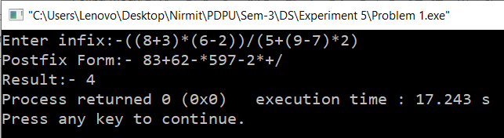
Time Complexity:- O(n) for infix to postfix where n would be number of expression in infix while O(m) for postfix evaluation where m would be the expression in postfix.
Space Complexity:- O(n)

